Bloodhound SSC Tour & Explore – A Circus of Practical Activities explaining the Science behind a 1000mph car.
This document is for guidance only; it is not a script that has to be followed exactly.
The ideas are prompts for the level of questions and answers needed for KS2 students.
The level of answers expected from KS2 students are stated in italic text. These are just examples, however, and more knowledge can be obtained from them if they are able to give it.
Resources
Practical | Resources required | Description
Aerodynamics | Umbrella | For health and safety, ensure any points on the umbrella are covered e.g. with a tennis ball
Cockpit | Carbon fibre samples | Material; sheet; strip
Reaction times | 4 x rulers | 1 ruler between a pair of students
Catalyst | https://www.youtube.com/watch?v=ezsur0L0L1c | Or see to see the risk assessment and demonstrate the practical yourself. http://www.sserc.org.uk/chemistry-resources/chemistry-demonstrations/3209-elephant-s-toothpaste
Rocket fuel | 20 transparent plastic cups  Vinegar (liquid fuel)  Bicarbonate of soda (solid fuel) | Fill 10 of the cups with a ¼ teaspoon of bicarbonate of soda  Fill 10 of the cups with a very small amount of vinegar (just a few mm in depth will be sufficient)  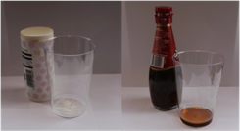  This provides enough for 10 groups, with each group receiving 1 cup of solid fuel and one cup of liquid fuel.
Compressed air | Balloon | This will be blown up to demonstrate compressed air
Combustion chamber | Crisps tube  Hairspray  Lighter  Balloon | 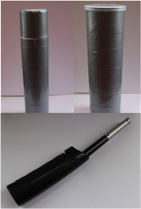
Nozzle - hairdryer | Hairdryer  Nozzle  Blown-up balloon | 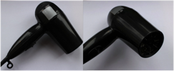  The hairdryer as it is needs to have a rounded, forward-facing nozzle:  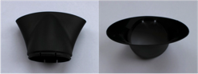  The additional nozzle needs to be a fanned-shape i.e. it will create a wider, less-directed stream of air:
Nozzle – airzookas | Large airzooka  Small airzookas (enough for 1 between 2 students)  Smoke machine(s) | Small airzookas need to be pre-made before the session, as there will not be enough time for students to make them themselves.  To prevent overheating, do not switch smoke machines on until the beginning of the session (or 10 minutes before this practical, if convenient)
Airbrakes | 2 x umbrellas | For health and safety, ensure any points on the umbrella are covered e.g. with a tennis ball
Parachutes | 2 x identical soft toys  Homemade parachute | 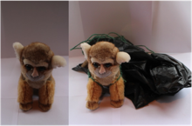  The parachute can be made out of bin liner and some string. It needs to be attached to one of the soft toys:
Friction | 2 x telephone books or catalogues | Alternating pages of each catalogue need to be folded on top of each other so that both of the catalogues are effectively interwoven:  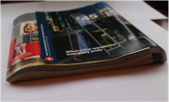

Display a photo of the Bloodhound Car.
- START AT THE NOSE CONE
Why is it this shape? It is pointed – to cut through the air.
Does anyone know the special name for this? Aerodynamics.
PRACTICAL: Give a volunteer an opened umbrella. Discuss how it affects them when walking in the wind – behind and in front of you – open and closed.
RESOURCES: Umbrella.
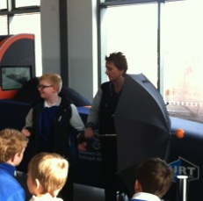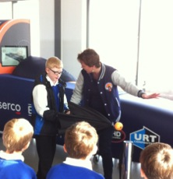
- MOVE TO COCKPIT
Discuss who sits in the cockpit and how the driver gets in and out.
Discuss safety. There is no ejector seat; why is this? Air intake for jet engine.
What things do we need to keep him safe? Air system, fire suppressant, clothes, etc.
The cockpit needs to be very strong. What might it be made from? Carbon fibre.
PRACTICAL: Show and pass around the carbon fibre samples. Emphasise the differences between the material and the sheets and also between the different strengths.
RESOURCES: Carbon fibre samples (material, sheet, strips).

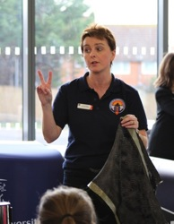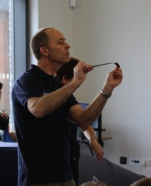
Explain how fast the car goes i.e. 4.5 football pitches in one second.
How long would it take to walk the length of 4.5 football pitches?
PRACTICAL: Get children to shut their eyes and open them again (one second). In the time it took them to do that, BLOODHOUND would have travelled the length of 4.5 football pitches.

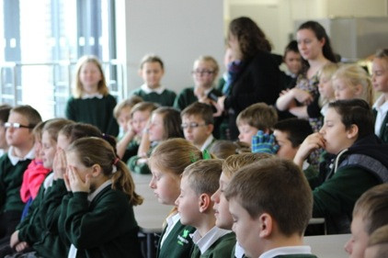
With the car travelling so fast, Andy Green needs to have very quick reaction times.
PRACTICAL: One student holds the ruler, zero down, just above the open thumb and finger of the other pupil. they drop the ruler without warning. They can compare reaction times by looking how far the ruler fell before they caught it.
- Drop the ruler whilst reciting two times tables.
- Drop the ruler whilst reciting two times tables and with stick in out-stretched arm in peripheral vision.
Do you get better or worse with practice?
RESOURCES: 8 x drop-sticks.
SAFETY: decide who will pick up a dropped ruler to avoid bumped heads.
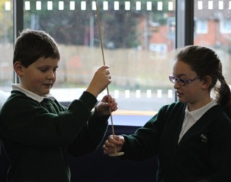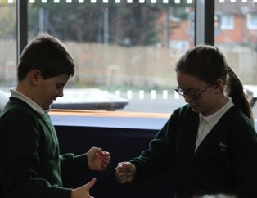

- MOVE TO THE ROCKET ENGINE
Ask students what they already know about the rocket.
Explain that there are three types of rocket:
- Liquid fuel (space rocket)
- Solid fuel (firework)
- Hybrid
What does hybrid mean? It has two things.
A hybrid rocket uses liquid fuel and rocket fuel. It can be turned on and off whereas the other two types of rocket cannot.
Explain the parts of the rocket:
Tank of liquid fuel (HTP; hair dye)
Rubber solid fuel (HTPB)
Catalyst (this changes the liquid fuel into steam and oxygen)
Catalyst is just a technical word for something that helps to create a change.
Analogy – you use a spoon to help make a cup of tea, but the spoon itself isn't used up.
Demonstrate, have four pupils holding hands representing a molecule of Hydrogen peroxide,
H-O-O-H, another pupil represents Nickel, the catalyst, who helps pull the pupils apart, then can then reform to make H-O-H and O. The Nickel catalyst helped the chemical reaction, as hydrogen peroxide changed to water and oxygen.

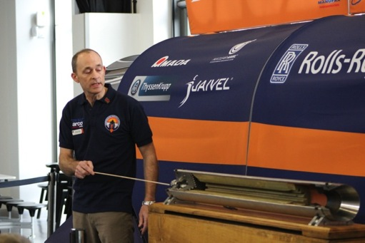

PRACTICAL: Human rocket engine. This further demonstrates how a rocket engine works.
Line up the whole class, with students facing the front.
Select a student in the middle to be the catalyst – they will shout ‘CHANGE’.
Students to the left of the catalyst will do a Mexican wave using just their right arm. They represent the liquid fuel.
Students to the right of the catalyst will do a Mexican wave with two arms and wiggling fingers. They represent the solid fuel burning.
The last 4 students will blow raspberries to represent thrust.
This is a chain reaction with one thing happening after another: one-armed Mexican wave – change! – two-armed Mexican wave with wiggling fingers – blowing raspberries.
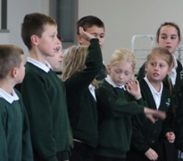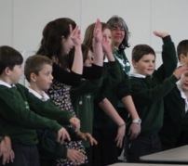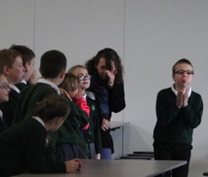

PRACTICAL: Making rocket fuel. Students need to be in groups of four. For each group:
Give one student a cup of solid rocket fuel (1/4 tsp of bicarbonate of soda)
Give one student a cup of liquid rocket fuel (a very small amount of vinegar)
Students need to silently and carefully tip the liquid into the other cup.
RESOURCES: 10 x cups containing bicarbonate of soda; 10 x cups containing vinegar.

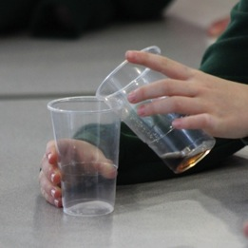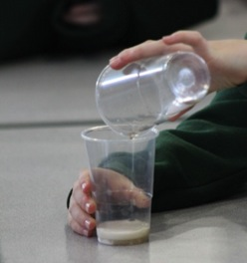
What happens? Can they hear anything? Bubbles are produced and there is a fizzing sound.
Why does this happen? The person pouring the fuel was acting as a catalyst and causing a change to occur. The bubbles are the gas being separated from the liquid. What can you feel? The reaction gives off heat, this represents the energy given off when fuel is burnt.
- MOVE TO THE JET ENGINE
Does anyone know how a jet engine works? SUCK – SQUEEZE-BANG-BLOW
Suck in air at the front (big fan)
Squash air (compresses) like a bike pump or balloon
Squashed air (compressed air) gets warm
Squashed air goes into a combustion chamber where we add fuel
Makes a spark- ignites - burns
Hot air and gas blows out the back causing thrust
PRACTICAL: Blow up a balloon and let it go to demonstrate compressed air.
RESOURCE: Balloon.

PRACTICAL: Human jet engine. Use 12 – 15 students to represent the different parts.
3 students: | 3 students: | 3 students: | 3 students: | 3 students:
Fan | Compressor | Adding fuel | Combustion chamber | Thrust
Wave arms around | Squeeze hands together | Squirting motion with hands | Clap hands | Blow raspberries

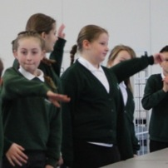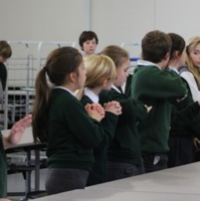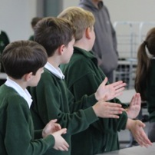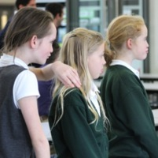
PRACTICAL: Demonstrate how a combustion chamber works. When filling the chamber with air, blow up a balloon and release this air into the tube. This gives the impression of compressed air.
RESOURES: Crisps tube, hairspray, lighter, balloon.

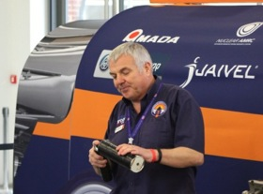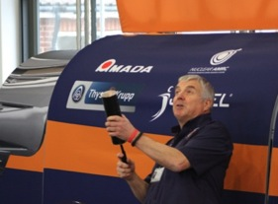
Discuss the engine nozzle – at the end of the jet engine there is something beginning with ‘n’; it is similar to what might be at the end of a hosepipe to direct water or used when icing a cake to direct the icing. Do you know what it is called? The nozzle.
The jet engine nozzle directs the power in the same way a hosepipe nozzle is used to direct water.
PRACTICAL: Use a hairdryer and a balloon to demonstrate how the directed air from the nozzle keeps the balloon in the air. Show the effects of different shaped nozzles. A wider nozzle will spread the air; there is less concentration of thrust so it is harder to keep the balloon up and control it. This demonstrates the importance of the nozzle shape. If there is time, ask a volunteer to have a go with the hairdryer and balloon.
RESOURCES: Hairdryer; wide nozzle.
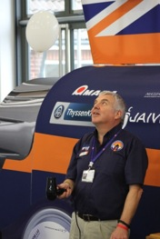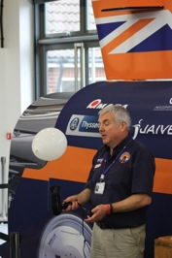
PRACTICAL: Use the large airzooka and the small airzookas to reemphasise the importance of the nozzle. The nozzle on the airzookas focuses the air to create thrust. This can be seen with smoke rings or even just by feeling the focused air coming out of it. The force from the airzookas punches a hole through the air to create thrust in the same way the nozzle of a jet engine directs thrust.
RESOURCES: Large airzooka; small homemade airzookas; smoke machine(s).
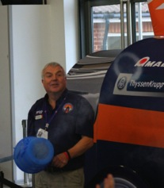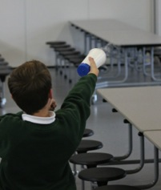
Using a smoke machine, fill the airzooka with smoke, then flick the bungee to create a smoke ring. Demonstrate that a ring is formed even if you can't see it – fire it into the faces of the pupils. (it doesn't hurt.) Watch the ring form – what is happening? The inside of the ring is moving faster than the outside.
Show how air is slowed down by friction as it pushes past the edge of the nozzle, air on the inside can move more quickly and flows around the slow air.
To make an airzooka, cut a small hole in a disposable frappucino cup, cut the end off a balloon, then attach the rubber pouch over the end of the cup with some tape. Pinching and releasing the rubber will create tiny vortices.

- MOVE ONTO WHEELS AND BRAKES
How do we stop the car? Turn off the engines or throttle; airbrakes; parachute.
How do the airbrakes work? Demonstrate with a practical.
PRACTICAL: Choose two volunteers and give each of them an opened umbrella. The volunteers need to push the umbrella through the air in front of them as quickly as possible.
RESOURCES: 2 x umbrellas.
SAFETY: Make sure other students are out of the way first.
What do the volunteers feel? It is hard to push the umbrellas through the air when they are open.
Pushing it through the air when it is open is harder than when it is shut due to increased air resistance. The shape is no longer aerodynamic, as it was before. This helps to slow the car down.
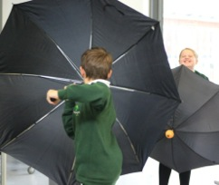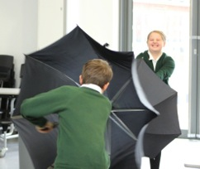
PRACTICAL: Demonstrate how a parachute can be used to slow something down by throwing two soft toys up in the air at the same time, one with a parachute and one without.
RESOURCES: 2 x identical soft toys; parachute.
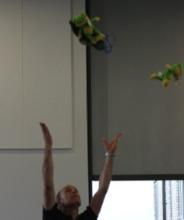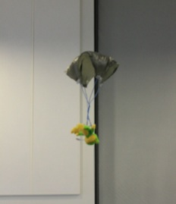
Which will fall to the ground first? Why? The one with the parachute because the parachute slows it down.
Why does the parachute slow it down? It catches the air or creates air resistance.
Explain that the parachute is not made particularly well but it is the job of engineers to design things, make them, test them and then improve them. Emphasise the relevance of STEM in making, designing and problem solving.
What is the problem with the parachute? How can it be improved? It is too small. It can be made bigger.
What about the wheels of the car? Are they special? Why?
No tyres
Very strong
Very light
Shape of rim
PRACTICAL: Get students to rub their hands together very quickly.
What do they notice? Their hands get hot.
Does anyone know what this force is called? Friction.
Friction is the force used to slow the wheels down. As well as airbrakes and parachutes, the car has disc brakes. These work by pushing down on the wheels and creating friction to slow them down and eventually stop them.
PRACTICAL: Get two volunteers to participate in the telephone book experiment to demonstrate how powerful a force friction is.
RESOURCES: 2 x telephone books.
The telephone books are acting like the disc brakes.

