**Curriculum links:**

Ask questions and develop a line of enquiry based on observations of the real world, alongside prior knowledge and experience.

Apply mathematical concepts and calculate results.

Use and derive simple equations and carry out appropriate calculations.

Speed and the quantitative relationship between average speed, distance and time (speed = distance ÷ time.)

|  |  |
| --- | --- |
| **Taxiway speeds** | |
| **Time (s)** | **Speed (mph)** |
| **0** | **0** |
| **10** | **0** |
| **20** | **7** |
| **30** | **12** |
| **40** | **19** |
| **50** | **23** |
| **60** | **27** |
| **70** | **27** |
| **80** | **30** |
| **90** | **33** |
| **100** | **40** |
| **110** | **43** |
| **120** | **49** |
| **130** | **40** |
| **140** | **29** |

**BLOODHOUND SSC: Testing a 1,000mph Jet Car**

1. The speed limit around the taxiway is 30mph. Did Andy go over this speed? Show your working



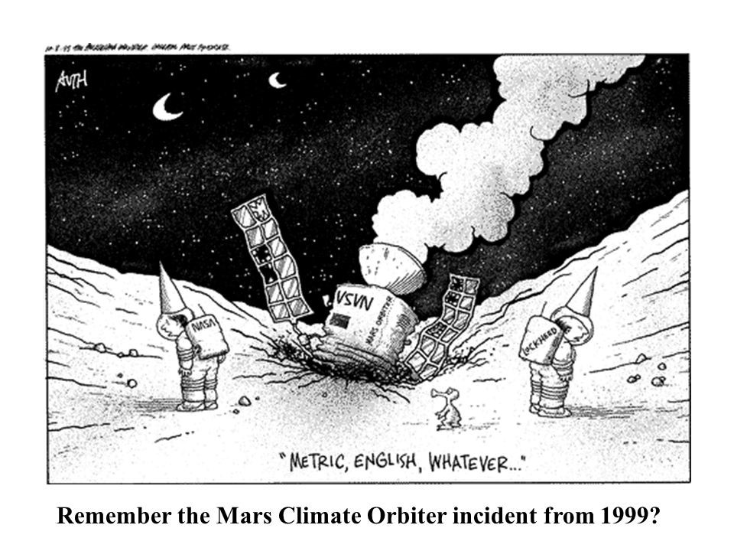

**2.) in 1999, the Mars Orbiter crashed, because the Engineers were using different units. Explain how you could convert 25mph into m/s.**

**1 mile = 1609 metres, 1 hour = 3600 seconds**

**3.) What speed was BLOODHOUND SSC going between 7 and 14 seconds from the start?**

4.) What is this car doing at each of these points in its journey?



C

A



D

B

For example, **Speed = Distance/ Time**

from 0-7seconds it travels

280-0m/7 = **40m/s**



5.) Now plot a graph to show BLOODHOUND SSC’s **speed** during the high speed testing run.

**An object accelerates when it’s speed is changing – At which point in the run did Bloodhound have the greatest rate of acceleration?**