Designing the shape of BLOODHOUND SSC
Dr. Letitia Sheridan
Principal Technical Writer
MathWorks

The BLOODHOUND SSC project aims to break the current Land Speed Record by attaining a speed of 1,000 miles per hour (1,609 kilometers per hour). At such speeds, the shape of the car is critical to keeping the car on the ground. Without a full understanding of the aerodynamics, we run the risk of having excess lift created when travelling at supersonic speeds, which could cause the vehicle to become airborne and endanger its driver, Andy Green.

The team working on designing the shape of the BLOODHOUND SSC used computer-aided modeling (Figure 1) to maximize performance while ensuring safety. The approach is also much less expensive than building multiple physical prototypes.

To design a safe car body shape, we needed to understand which design parameters had the strongest influence on the lift at the rear of the car. We used the following process:

- Use design of experiments to gather sufficient data on the most important parameters as quickly as possible
- Collect data at the points identified by the design of experiments using a computational fluid dynamics model
- Fit a statistical model to the data, and use this model quickly evaluate the lift generated by many possible shapes of the car
- Run simulations of the model to find the optimal combination of parameters to minimize lift
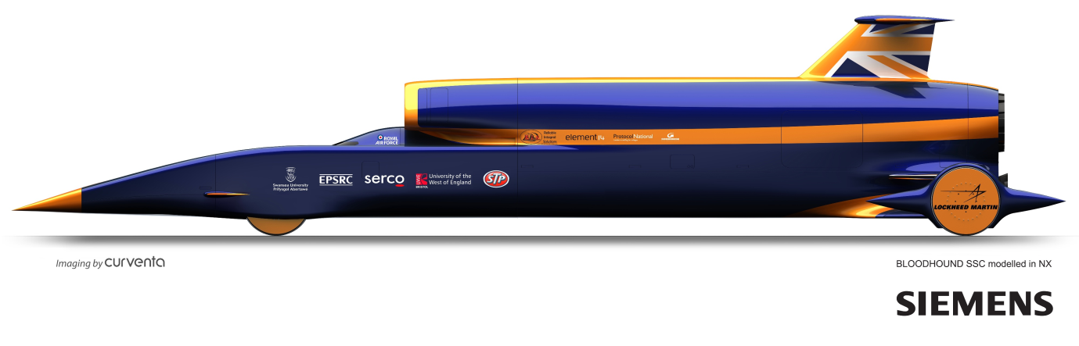

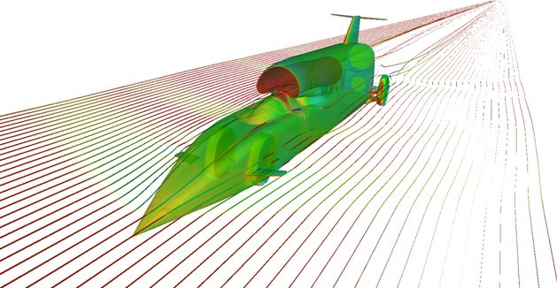
Figure 1. The BLOODHOUND SSC (top) and results from an aerodynamic simulation (bottom).

Identifying Key Design Features

Of the 18 factors investigated, six design features were identified by the engineering design team as the most important in reducing lift without adversely affecting the vehicle drag. Of those, the rear wheel track width was so significant, that we made the decision to fix it at a single, minimized value that was not varied during the Design of Experiments (DoE).

The remaining five key design factors affecting rear lift were:
- Delta leading edge sweep angle
- Delta angle of attack
- Base area (or cone)
- Boat-tail angle
- Cross-sectional shape

Delta is a term we used to refer to the filled-in part of the lower rear suspension. It is designed to improve the aerodynamics of the underside of the car and prevent supersonic shock waves from traveling underneath the car and causing lift. Viewed from above the car, it forms a triangle, hence the name delta (Figure 2).
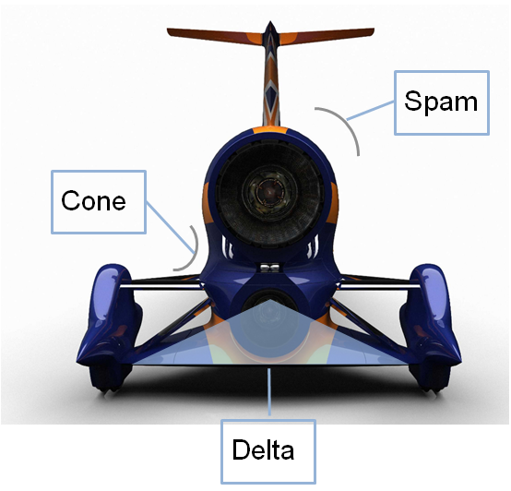
Figure 2. The BLOODHOUND SSC viewed from the rear.

The angles of the delta — specifically the angle of attack (AoA) and the angle of the leading edge (LE) — are very important for controlling the lift at the back of the car. The AoA is the angle between the car body and the delta (Figure 3).
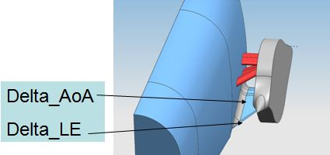
Figure 3. The delta angle of attack and leading edge.

The base area (or cone) refers to the streamlined shape of the back of the car. It appears as if half a cone has been removed from each side of the car so that they hug the lines of the jet and rocket engines (Figure 4). The size of these half-cones influences the aerodynamics of the vehicle.
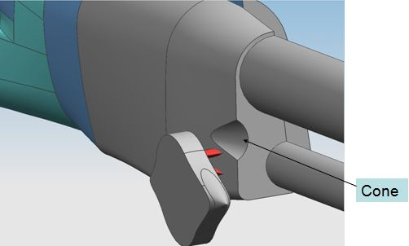
Figure 4. The half-cone shaped indentation at the back of the car.

The boat-tail angle is related to the rump, which is the point along the rear of the car at which the body starts to narrow (Figure 5). The location of this narrowing point can vary from forward of the rear wheel to some point behind them, and selecting the optimal point as measured in millimeters from the rear face was a key design factor.

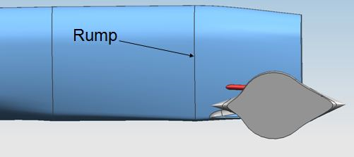
Figure 5. The vehicle’s rump.

We used the term spam to refer the vehicle’s cross sectional shape, specifically the angle of the sides. The design parameter here is the angle of the sides in degrees from vertical (Figure 6). The name was first used to describe an early design variant in which the cross-section resembled the traditional shape of a canned meat product.
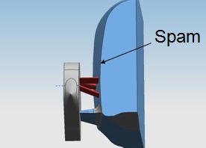
Figure 6. The vehicle’s cross-sectional shape, or spam factor

The Design of Experiments

We had developed a detailed computational fluid dynamics (CFD) model of BLOODHOUND SSC that yielded accurate results. The CFD model had been extensively tested against standard CFD test cases in the research literature. This CFD model, however, is computationally expensive. Each CFD simulation took half a day to run using a large parallel supercomputer, so it was not feasible to simply run optimizations directly on the detailed CFD model.

Efficient optimization requires a much faster statistical model, which we created based on results generated from the CFD model. Given the lengthy computations required for each CFD point, we wanted to collect data from the CFD only at the most useful points, and then create a statistical model from those points.

Design of Experiments is a method for identifying the best sampling points for collecting the data needed for a statistical model in the shortest amount of time. We used MATLAB and DoE tools in Model-Based Calibration Toolbox to select the design parameters for gathering the most statistically useful data. Based on that data, we could then create a statistical model that accurately describes the behaviour of the CFD model, but runs much faster (typically in milliseconds), enabling efficient optimization of the design shape to minimize the car’s rear lift.

To begin, we ran several simulations using the CFD model while varying the values of the five parameters. Based on these preliminary simulation results, we used engineering knowledge to guess what the right model shape should be to best fit the shape of the gathered data. We predicted we could use a quadratic model.

We used Design of Experiments to pick the simplest design style that would give us enough data to fit a quadratic model accurately. We chose a Central Composite Design (CCD) style, which has enough design points to estimate the coefficients in a quadratic model. The design points include a factorial design (the corners of a cube) together with a center point and star points in the middle of each face of the cube (Figure 7). The sides of the cube represent the design variables, thus the cube shown in Figure 7 represents a three variable design space.

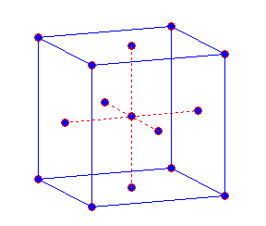
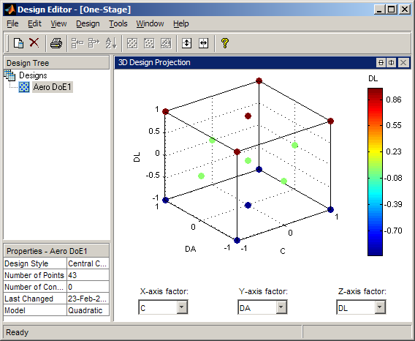

Figure 7. The Central Composite Design style for a quadratic model.

To produce an accurate statistical model of rear lift, we needed to simulate 43 slightly different models with varying values for the five key variables. We needed 43 models because there were 5 parameters hence $2^{5}$ vertices plus $2×5$ centre of faces plus 1point at the centre adding up to 43 in total. We generated a design with 43 different points, and simulated these points in the CFD model to collect the data by varying the geometry of the CFD mesh that defines the shape being studied.

Fitting a Statistical Model to the Data
Next, we needed to fit a statistical model to the rear lift data and select the best fit. We expected that a quadratic model would be the best fit for lift, but we investigated other model types to check our assumption. We tried several options ranging from a simple linear model (one with only five parameters, a plane in each variable) to more sophisticated models with radial basis functions, which are capable of fitting complicated surfaces.

We measured the root mean squared error (RMSE) between the statistical model results and the CFD model results to evaluate the quality of each model. The simplest model, we found, was the best choice. The more complicated models were not necessary to describe the simple relationships between the variables. Plots of the models showed that the curve of a quadratic would not be necessary to model the flat plane relationships between the variables (Figures 8 and 9).

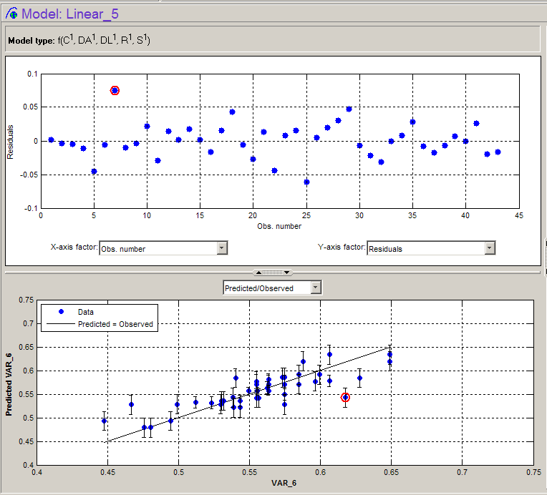
Figure 8. Plot of predicted versus observed data for the linear model.
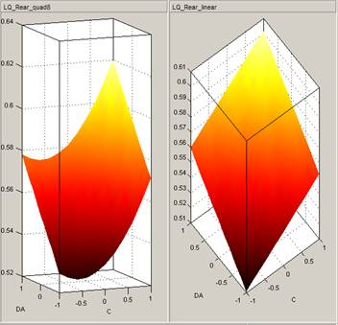
Figure 9. Quadratic model results (left) and linear model results (right).

After confirming that the quadratic model was no better than the linear we opted to use the simpler linear model. In general it’s a best practice to select the model that uses the fewest parameters to describe the data. The quadratic model had more parameters than the linear model, and there was little difference in the RMSE, so we selected the linear model.

Finding an Optimal Set of Parameters
Now that we had a model that accurately described how the five design parameters influenced the lift, we used the model to find the optimal combination of parameter values to minimize the lift. We applied a nonlinear optimization algorithm from Optimization Toolbox to find the best solution.

The optimization algorithm moves along gradients to find minima (Figure 10).
Plots of lift (the optimization objective) against each of the five variables showed that the optima are all at one edge of the range except for the delta leading edge (DL), which is flat, so any value works as well as any other. This is certainly not something we would have been able to predict in advance of this study. In short, to minimize lift, we need to minimize the cone, delta angle of attack, and spam parameters while maximizing the rump parameter.
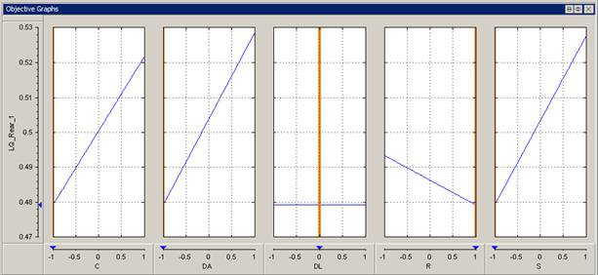
Figure 10. Plots of lift versus (from left to right) cone, delta angle of attack, delta leading edge, rump, and spam design parameters for the linear model. Orange bars show the solution identified by the optimizer.

To check our results, we also ran the optimization with the quadratic model. The optimizer found very similar solutions (Figure 11). The exception was that the cone parameter was close to, but not at, its minimum value

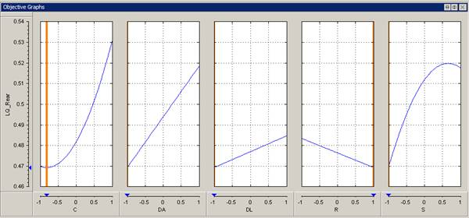
Figure 11. Plots of lift versus design parameters for the quadratic model.

The results of this optimization helped determine the back-end shape for the config10 design of the BLOODHOUND SSC.

Prior to config10, the back end of the BLOODHOUND SSC was experiencing about 10 tons of lift at supersonic speeds. With the design changes suggested by this analysis the lift is nearly neutral at supersonic speeds (BLOODHOUND SSC, 2010).

BLOODHOUND SSC - http://www.bloodhoundssc.com/news/latest_news.cfm?widCall1=customWidgets.contentItem_show_1&cit_id=4769

